**CSS 475 Group Project**

Completed Project Due: 16 March 2021

Participants: Christopher Hovsepian, Ethan Mo, Tanner Hanay, Marci Ma, Xue Guan

Project: Airport Database

**Assumptions**:

* Ground crew can walk around to any gate attached to the runway they are assigned to.
* Because Gate is a weak entity to terminal and runway, the aircraft will land at a runway….
* 1 airport has multiple runways, 1 runway has multiple terminals, 1 terminal has multiple gates
* Employees could be assigned to runway and terminal

**Entity Relationship Diagram**

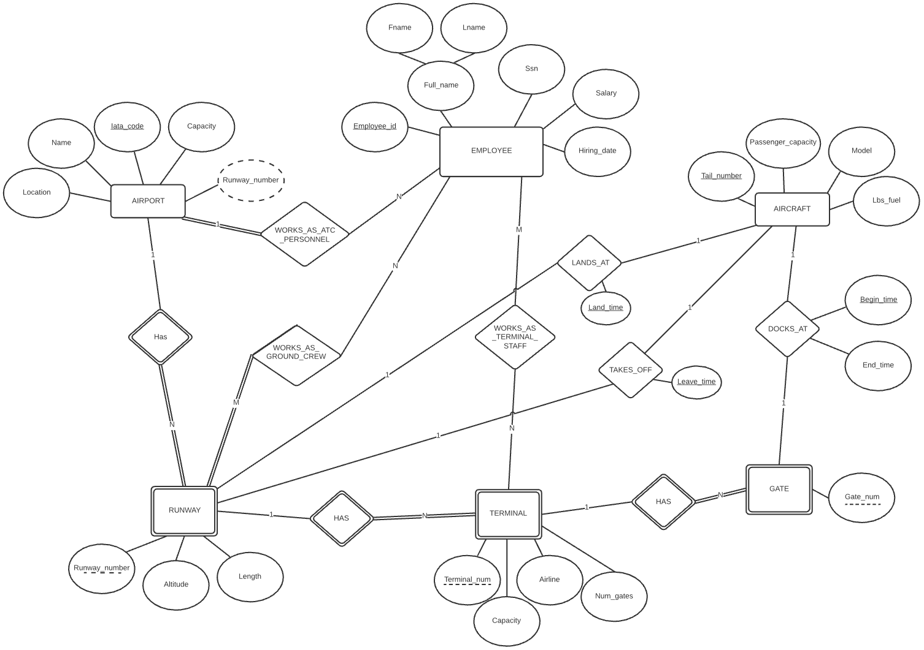

**Relational Data Model**

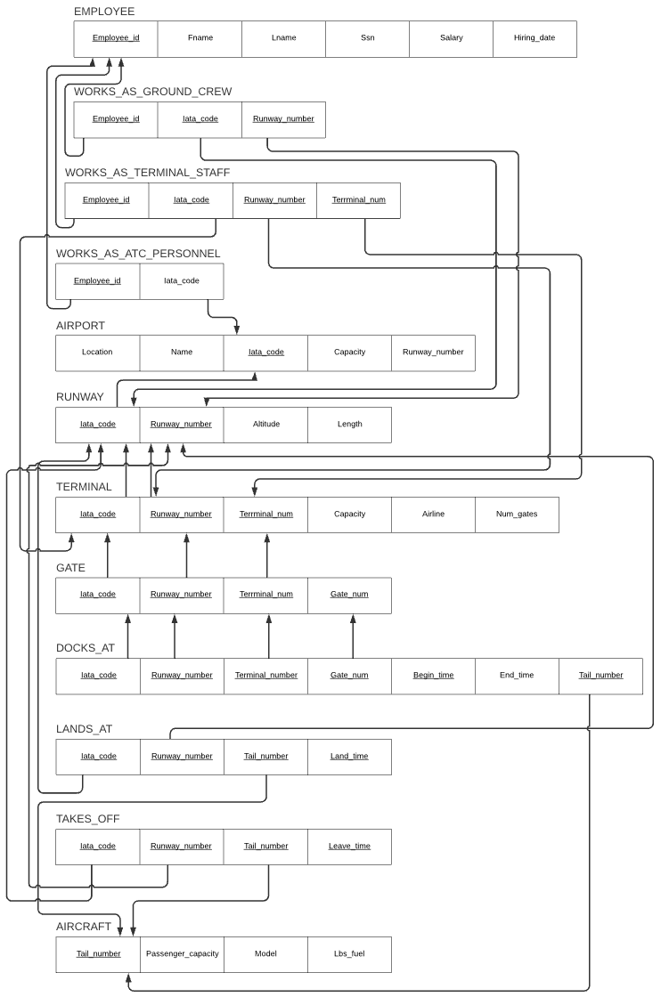

**Project Evaluation**:

Since the assignment was assigned we met for three hours every Friday to complete each task.

What went right:

We used lucidchart, google docs, and discord to collaborate on this project. Google docs was used for writing SQLite statements and these discussions. Lucidchart was used for making the ER diagram and Relational Data Model. Discord was used for its voice chat and for sharing links. We were able to meet every week and had no schedule issues. We planned out what we were going to do each week, and were able to finish the portion that we planned. We submitted it on time.

What went wrong:

Nothing, we are amazing. On a serious note, we did not run into any serious issues. We had to change a few things about our ER diagram once we started our Relational Data Model which waisted some time. When making our SQL statements we had some issues with the datetime format, we did research about how to use it while creating tables and queries, and resolved them eventually.

What would we do differently:

We should check if all the entities on the ER diagram can be mapped to the relational Data Model, so that we can avoid editing the ER diagram while doing the Relational Data Model.

**NF Disscussion**:

**EMPLOYEE** meets all the requirements for BCNF. Employee_id is the key, and Ssn is a secondary key. There are no nested attributes, it meets full FD, and only the key can be used to determine the non-keys. This meets BCNF because the left side is only a candidate key.

**WORKS_AS_GROUND_CREW** meets all the requirements for BCNF. Because all attributes are used as keys, it meets 1, 2, 3NF, and BCNF.

**WORKS_AS_TERMINAL_STAFF** meets all the requirements for BCNF. Because all attributes are used as keys, it meets 1, 2, 3NF, and BCNF.

**WORKS_AS_ATC_PERSONNEL** meets all the requirements for BCNF. Because all attributes are used as keys, it meets 1, 2, 3NF, and BCNF.

**AIRPORT** meets all the requirements for BCNF. Iata_code is the primary key, and Location and Name together are a secondary key. There are no nested attributes, it meets full FD, and only the keys can be used to determine the non-keys. The left side is a candidate key only, so it meets BCNF.

**RUNWAY** meets all the requirements for BCNF. There are no nested attributes, it meets full FD, and only the keys can be used to determine the non-keys, not vice versa.

**TERMINAL** meets all the requirements for BCNF. There are no nested attributes, it meets full FD, and only the keys can be used to determine the non-keys, not vice versa.

**GATE** meets all the requirements for BCNF. Because all attributes are used as keys, it meets 1, 2, 3NF, and BCNF.

**DOCKS_AT** meets all the requirements for BCNF. Because all but one attributes are used as keys, it meets 1, 2, 3NF. Because the key is on the left, and the only attribute is on the right, this meets BCNF.

**LANDS_AT** meets all the requirements for BCNF. Because all attributes are used as keys, it meets 1, 2, 3NF, and BCNF.

**TAKES_OFF** meets all the requirements for BCNF. Because all attributes are used as keys, it meets 1, 2, 3NF, and BCNF.

**AIRCRAFT** meets all the requirements for BCNF. There are no nested attributes, it meets full FD, and only the keys can be used to determine the non-keys, there's no non-key determining key.

**SQL Statement:**

|  |  |
| --- | --- |
| **SQL Statement** | **Purpose** |
| Select tail_number, land_time  From LANDS_AT  Where Land_time > '2020-03-05 00:00:00' AND  Land_time < '2020-03-06 00:00:00'; | List of flights that arrived that day |
| Select Tail_number, Leave_time  From TAKES_OFF  Where Leave_time > '2020-03-05 00:00:00' AND  Leave_time < '2020-03-06 00:00:00'; | List of fights that left that day |
| Select Tail_number  From DOCKS_AT  Where End_time is null; | List Aircraft tail numbers that are currently docked to a terminal |
| Select tail_number  From LANDS_AT  Where tail_number not in (Select tail_number From DOCKS_AT); | List Aircraft tail numbers that are waiting to dock with the terminal |
| Select avg(salary)  From employee e, WORKS_AS_ATC_PERSONNEL  where e.Employee_id = w.Employee_id; | Average salary of air traffic control workers |
| Select count(iata_code)  from TAKES_OFF  Where Leave_time > '2020-02-26 00:00:00' AND  Leave_time < '2020-03-04 00:00:00'; | Number of flight departures over the last week. |
| Select Employee_id, fname, lname  from employee  where salary < 40000; | List the employee name and employee ID having salary under $40,000 |
| Select Employee_id, Salary  From EMPLOYEE  Order by Salary desc; | List all the employe ID numbers and orders them by salary decreasingly |
| Select gate_num, airline  From GATE g, TERMINAL t  Where g.runway_number = '34R' and g.Runway_number = t.Runway_number  Group by g.Terminal_num; | List the gate number and airline info, for aircraft that landed at runway ‘34R’ and is grouped by terminal number. |

**/// SQLite**

.open finalproject.db

.mode column

.headers on

pragma table_info(EMPLOYEE);

pragma table_info(WORKS_AS_GROUND_CREW);

pragma table_info(WORKS_AS_TERMINAL_STAFF);

pragma table_info(WORKS_AS_ATC_PERSONNEL);

pragma table_info(AIRPORT);

pragma table_info(RUNWAY);

pragma table_info(TERMINAL);

pragma table_info(GATE);

pragma table_info(DOCKS_AT);

pragma table_info(LANDS_AT);

pragma table_info(TAKES_OFF);

pragma table_info(AIRCRAFT);

drop table EMPLOYEE;

drop table WORKS_AS_GROUND_CREW;

drop table WORKS_AS_TERMINAL_STAFF;

drop table WORKS_AS_ATC_PERSONNEL;

drop table AIRPORT;

drop table RUNWAY;

drop table TERMINAL;

drop table GATE;

drop table DOCKS_AT;

drop table LANDS_AT;

drop table TAKES_OFF;

drop table AIRCRAFT;

create table EMPLOYEE

(

Employee_id char(10) not null,

Fname varchar(15) not null,

Lname varchar(15) not null,

Ssn char(9) not null,

Salary decimal(10,2),

Hiring_date date(8),

Primary Key (Employee_id),

Unique (Ssn)

);

create table WORKS_AS_GROUND_CREW

(

Employee_id char(10) not null,

Iata_code varchar(4) not null,

Runway_number varchar(5) not null,

Primary Key (Employee_id, Iata_code, Runway_number),

Foreign key (Employee_id)

references EMPLOYEE(Employee_id)

on update cascade on delete set null,

Foreign key (Iata_code, Runway_number)

references RUNWAY(Iata_code, Runway_number)

on update cascade on delete set null

);

create table WORKS_AS_TERMINAL_STAFF

(

Employee_id char(10) not null ,

Iata_code varchar(4) not null ,

Runway_number varchar(5) not null ,

Terminal_num int not null,

PRIMARY KEY (Employee_id, Iata_code, Runway_number, Terminal_num),

Foreign key (Employee_id) references EMPLOYEE(Employee_id) on update cascade on delete set null,

Foreign key (Iata_code, Runway_number, Terminal_num)

references TERMINAL(Iata_code, Runway_number, Terminal_num)

on update cascade on delete set null

);

create table WORKS_AS_ATC_PERSONNEL

(

Employee_id char(10) not null,

Iata_code varchar(4) not null,

PRIMARY KEY(Employee_id),

Foreign key(Iata_code) references Airport(Iata_code) on update cascade on delete cascade,

Foreign key (Employee_id) references EMPLOYEE(Employee_id) on update cascade on delete set null

);

create table AIRPORT

(

Location varchar(50),

Name varchar(50) not null,

Iata_code varchar(4),

Capacity INT,

Runway_number,

primary key(Iata_code),

unique(Name)

);

create table RUNWAY

(

Iata_code varchar(4) not null ,

Runway_number varchar(5) not null ,

Altitude int,

Length int,

Primary key (Iata_code, Runway_number),

Foreign key (Iata_code) references AIRPORT(Iata_code) on update cascade on delete cascade

);

create table TERMINAL

(

Iata_code varchar(4) not null,

Runway_number varchar(5) not null,

Terminal_num int not null,

Capacity int,

Airline varchar(30),

Num_gates int,

Primary key(Iata_code, Runway_number, Terminal_num),

Foreign key(Iata_code, Runway_number)

references RUNWAY(Iata_code, Runway_number)

on update cascade on delete cascade

);

create table GATE

(

Iata_code char(4) not null,

Runway_number varchar(5) not null,

Terminal_num int not null,

Gate_num varchar(3),

primary key (Iata_code, Runway_number, Terminal_num, Gate_num),

Foreign key (Iata_code, Runway_number, Terminal_num)

references TERMINAL(Iata_code, Runway_number, Terminal_num)

on update cascade on delete cascade

);

create table DOCKS_AT

(

Iata_code varchar(4) not null ,

Runway_number varchar(5) not null ,

Terminal_num int not null,

Gate_num varchar(3),

Begin_time datetime not null,

End_time datetime,

Tail_number varchar(10)not null,

Primary Key (Iata_code, Runway_number , Terminal_num, Gate_num, Begin_time, Tail_number),

Foreign key (Iata_code, Runway_number , Terminal_num, Gate_num)

references GATE(Iata_code, Runway_number , Terminal_num, Gate_num)

on update cascade on delete set null,

Foreign key (Tail_number) references AIRCRAFT(Tail_number) on update cascade on delete set null

);

create table LANDS_AT

(

Iata_code varchar(4) not null,

Runway_number varchar(5) not null,

Tail_number varchar(10) not null,

Land_time datetime not null,

PRIMARY KEY(Iata_code, Runway_number, Tail_number, Land_time),

Foreign key(Iata_code, Runway_number) references RUNWAY(Iata_code, Runway_number) on update cascade on delete cascade

Foreign key(Tail_number) references AIRCRAFT(Tail_number) on update cascade on delete cascade

);

create table TAKES_OFF

(

Iata_code varchar(4) not null,

Runway_number varchar(5) not null,

Tail_number varchar(10) not null,

Leave_time datetime,

PRIMARY KEY(Iata_code, Runway_number, Tail_number, Leave_time),

Foreign key(Iata_code, Runway_number) references RUNWAY(Iata_code, Runway_number) on update cascade on delete cascade

Foreign key(Tail_number) references AIRCRAFT(Tail_number) on update cascade on delete cascade

);

create table AIRCRAFT

(

Tail_number varchar(10),

Passenger_capacity int,

Model varchar(10),

Lbs_fuel int,

primary key (Tail_number)

);

**//// Populating the Tables**

.tables

Insert into EMPLOYEE

values

('9123123123', 'Bob', 'Smith', '000111222', 40000.00, 2015-01-01),

('8323123123', 'Billybob', 'Smith', '333111555', 45000.00, 2016-11-05),

('8323123555', 'Adam', 'Smith', '444777555', 47000.00, 2013-05-22),

('9090123120', 'Sponge', 'Bob', '888444000', 37000.00, 2020-06-24);

Insert into WORKS_AS_GROUND_CREW

Values

('9123123123', 'SEA', '34R'),

('8323123123', 'SEA', '34R');

Insert into WORKS_AS_TERMINAL_STAFF values ('8323123555', 'SEA', '34R', '5');

Insert into WORKS_AS_ATC_PERSONNEL values ('9090123120', 'SEA');

insert into AIRPORT

values

('Seattle', 'Seattle-Tacoma International Airport', 'SEA', 15000, 3),

('Atlanta', 'Hartsfield-Jackson Atlanta International Airport', 'ATL', 20000, 5),

('New York', 'John F. Kennedy International Airport', 'JFK', 18000, 4);

Insert into RUNWAY

values

('SEA', '34R', 385, 11901);

Insert into TERMINAL

values

('SEA', '34R', 1, 6000, 'Alaska Airlines', 10);

Insert into GATE

values

('SEA', '34R', 5, 'A10'),

('SEA', '34R', 5, 'A11'),

('SEA', '34R', 5, 'A12'),

('SEA', '34R', 2, 'B5'),

('SEA', '34R', 2, 'B6');

Insert into DOCKS_AT

values

('SEA', '34R', 1, 'A12', '2020-03-05 02:48:10', NULL, 'FG12451'),

('SEA', '34R', 1, 'B6', '2020-03-05 01:28:13', NULL, 'GWA1512'),

('SEA', '34R', 1, 'B5', '2020-03-05 11:28:13', '2020-03-05 02:38:22', 'GH21512');

insert into LANDS_AT

values

('SEA', '34R', 'FG12451', '2020-03-05 02:43:10');

insert into TAKES_OFF

values

('SEA', '34R', 'FG12451', '2020-03-05 03:39:10');

insert into AIRCRAFT

values

('FG12451', 150, 'B734', 1000),

('GWA1512', 200, 'B737', 1500),

('GH21512', 100, 'AC90', 900),

('JHU6823', 90, 'CL2T', 500),

('OIU16191', 10, 'CRJ9', 600);

**//// SQL statements (that provide functionality)**

Select tail_number, land_time

From LANDS_AT

Where Land_time > '2020-03-05 00:00:00' AND

Land_time < '2020-03-06 00:00:00';

//List of flights that arrived that day

Select Tail_number, Leave_time

From TAKES_OFF

Where Leave_time > '2020-03-05 00:00:00' AND

Leave_time < '2020-03-06 00:00:00';

//List of fights that left that day

Select Tail_number

From DOCKS_AT

Where End_time is null;

//Aircraft tail numbers that are currently docked to a terminal

Select tail_number

From LANDS_AT

Where tail_number not in (Select tail_number From DOCKS_AT);

//Aircraft tail numbers that are waiting to dock with the terminal

Select avg(salary)

From employee e, WORKS_AS_ATC_PERSONNEL w

where e.Employee_id = w.Employee_id;

//Average salary of air traffic control workers (aggregation)

Select count(iata_code)

from TAKES_OFF

Where Leave_time > '2020-02-26 00:00:00' AND

Leave_time < '2020-03-04 00:00:00';

//Number of flight departures over the last week. (aggregation)

Select Employee_id, fname, lname

from employee

where salary < 40000;

//Select from the ID number column, first name, last name from employee table, having salary under $40,000

Select Employee_id, Salary

From EMPLOYEE

Order by Salary desc;

// this lists all the employe ID numbers and orders them by salary decreasingly

Select gate_num, airline

From GATE g, TERMINAL t

Where g.runway_number = '34R' and g.Runway_number = t.Runway_number

Group by g.Terminal_num;

// List the gate number and airline info, for aircraft that landed at runway ‘34R’ and is grouped by terminal number.

Select * from EMPLOYEE;

select * from AIRCRAFT;

select * from AIRPORT;

select * from DOCKS_AT;

select * from EMPLOYEE;

select * from GATE;

select * from LANDS_AT;

select * from RUNWAY;

select * from TAKES_OFF;

select * from TERMINAL;

select * from WORKS_AS_ATC_PERSONNEL;

select * from WORKS_AS_GROUND_CREW;

select * from WORKS_AS_TERMINAL_STAFF;